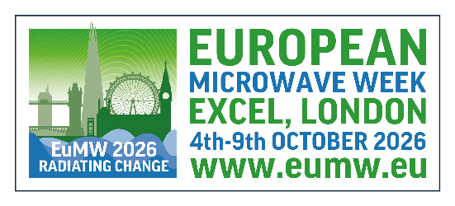
European Microwave Week: Request for Grants
Applicant Name and date of birth (Please type or print clearly as shown on passport):
Title |  | First name | Middle name |  |  | Last name
Date of birth:
Email: |  |  | Phone:
Curriculum Vitae |  |  |  |  | ☐ attached (required)
Copy of passport |  |  |  |  | ☐ attached (required)

Applicant Address: ☐ Company ☐ University
☐ Research Institute
☐ Government

Institution:
Street:
City: |  |  | State/Province:
ZIP/Postal Code: |  |  | Country:
Paper references (only for applicant (co)authors of a submitted paper at EuMW 2026):
Title(s):

Grant requested (either student grant OR travel grant):
Student grant:  (select only one)  ☐EuMIC  ☐EuMC  ☐EuRAD | Applicants for a Student Grant must have their 31st birthday after the end of 2026 and be full time student (i.e. B.Sc., M.Sc. Ph.D. student). The value of the grant is €750 plus a voucher for complimentary attendance at the selected conference.  When applying for a Student Grant, you are no longer eligible for a Travel Grant.
Student grant:  (select only one)  ☐EuMIC  ☐EuMC  ☐EuRAD | Supervisor name
Student grant:  (select only one)  ☐EuMIC  ☐EuMC  ☐EuRAD | Supervisor email
Student grant:  (select only one)  ☐EuMIC  ☐EuMC  ☐EuRAD | Letter of recommendation from supervisors including confirmation of current student status and a motivation why the student should receive a grant. |  | ☐ attached  (required)

Travel  grant:  (select only one)  ☐EuMIC  ☐EuMC  ☐EuRAD | Applicants for a Travel Grant must be residents of one of the following countries: Algeria, Armenia, Azerbaijan, Belarus, Egypt, Estonia, Georgia, Jordan, Kazakhstan, Kyrgyzstan, Latvia, Lebanon, Libya, Lithuania, Mauritania, Moldova, Morocco, Syria, Tajikistan, Tunisia Turkmenistan, Ukraine, Uzbekistan. The value of the grant is €750 plus a voucher for complimentary attendance at the selected conference. When applying for a Travel Grant, you are no longer eligible for a Student Grant.
Travel  grant:  (select only one)  ☐EuMIC  ☐EuMC  ☐EuRAD | State reasons why you should be given this grant (max 200 characters):
By signing this document, I certify the information provided in and attached to this form is true, accurate and complete. Failure to comply with this, in this form, in its attachments or in any other supporting document, will lead to automatic disqualification.

Applicants signature Place and Date

