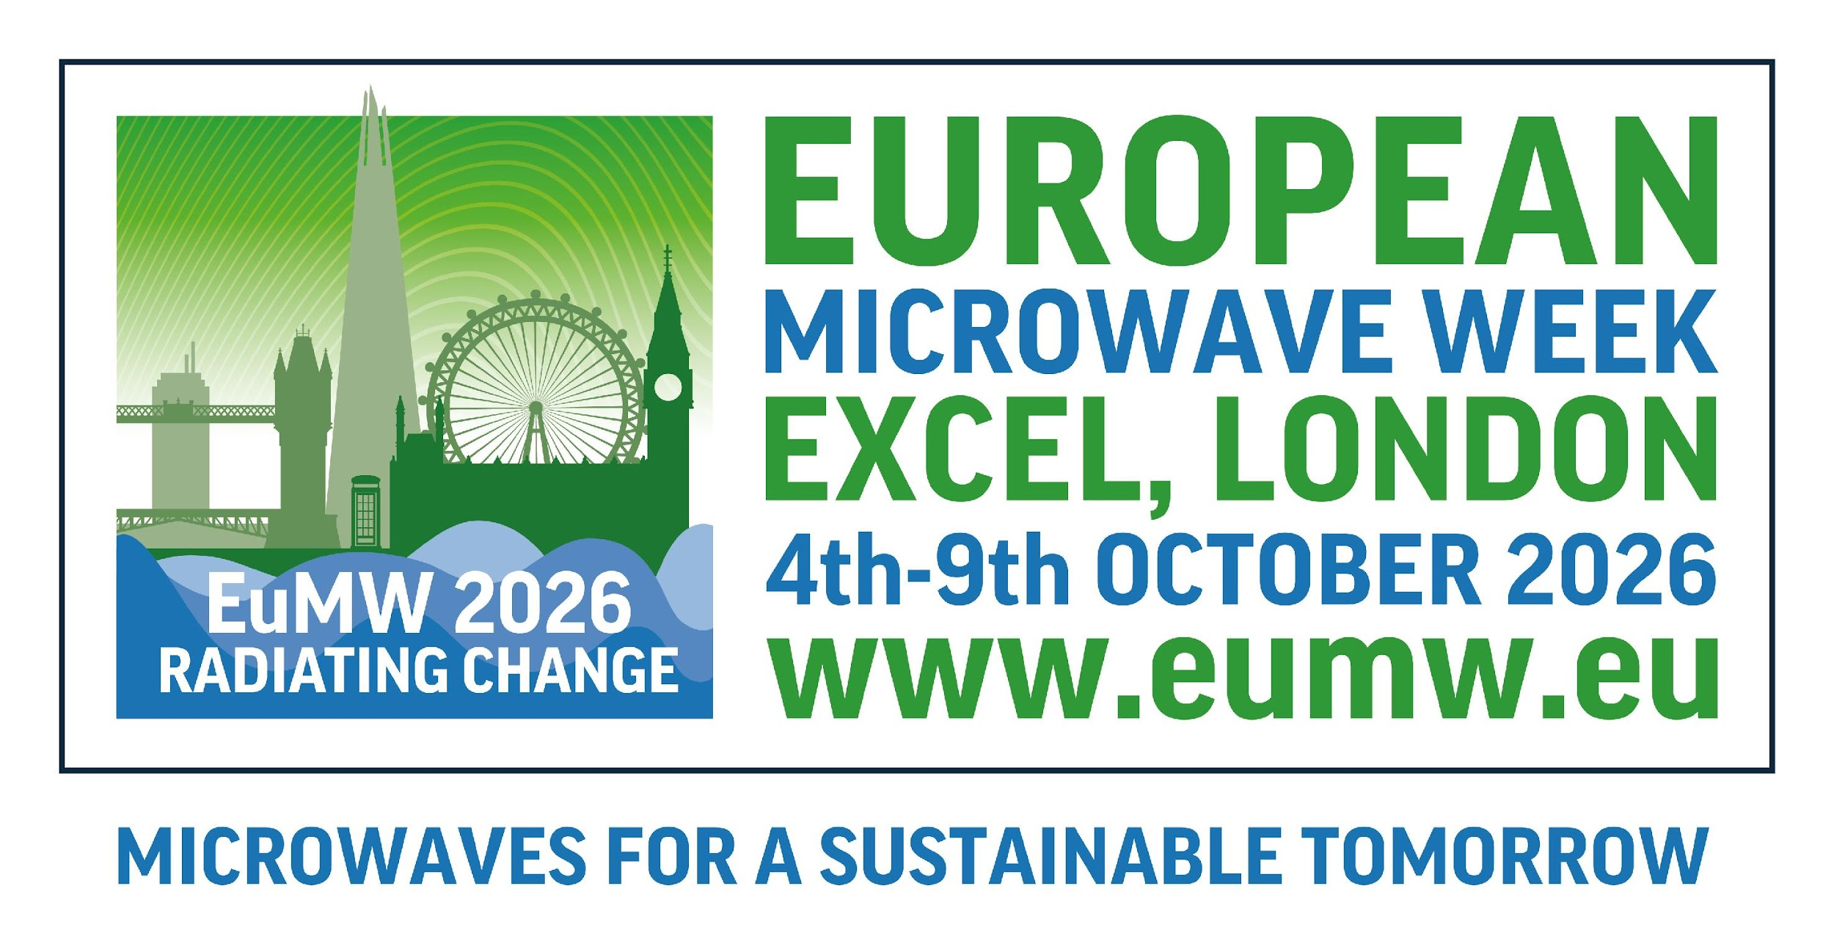
2026 European Microwave Week
Focussed/Special Session Proposal

Deadline for submission of proposals is February 8, 2026.

In case of any questions please contact the General TPC Chairs at: focused.sessions.eumw2026@eumwa.org

Organiser(s)

Name:  Affiliation:  Email:  Phone: | Name:  Affiliation:  Email:  Phone:

Type: | Focussed Session ☐  Special Session ☐
Conference: | EuMC ☐  EuMIC ☐  EuRAD ☐

Focussed/Special Session Title: ___________________________________________________________

Topic: _______________________________________________________________________________

Expected Attendance: __________________________________________________________________
Focussed/Special Session Abstract (max 250 words):

Important Information
- Accepted Focussed/Special Sessions will be scheduled for one of the days of the EuMW 2026. The assigned date and time slot cannot be disputed and the organisers are expected to inform the speakers accordingly.
- The speakers will need to register for the corresponding conference. Registration fees will not be waived.

I have read and understood the above important information and shared this information with all the speakers who also understood: _________ (Yes/No)

Please complete the rest of the form only if your answer to the above question is “Yes”.

In case of a Focussed Session please note the following.
Papers for a Focussed Session are subject to the normal review process. So unexpectedly a submission to a Focussed Session may be rejected. Therefore, the organisers of a Focussed Session are strongly advised to provide six or seven speakers, such that a full session can be arranged even if a submission is rejected.

If more than five papers are accepted for a Focussed Session, the organisers are free to select five papers for their session. The remaining paper(s) will be included in regular scientific sessions of the appropriate conference.

Speakers

1. Speaker's Name: | Confirmed (yes/no):
Affiliation:
Presentation Title:
Speaker’s Email:
Summary (2-3 sentences):

2. Speaker's Name: | Confirmed (yes/no):
Affiliation:
Presentation Title:
Speaker’s Email:
Summary (2-3 sentences):

3. Speaker's Name: | Confirmed (yes/no):
Affiliation:
Presentation Title:
Speaker’s Email:
Summary (2-3 sentences):

4. Speaker's Name: | Confirmed (yes/no):
Affiliation:
Presentation Title:
Speaker’s Email:
Summary (2-3 sentences):

5. Speaker's Name: | Confirmed (yes/no):
Affiliation:
Presentation Title:
Speaker’s Email:
Summary (2-3 sentences):

In case of a Focussed Session, it is strongly advised to provide an additional one or two speakers:

6. Speaker's Name: | Confirmed (yes/no):
Affiliation:
Presentation Title:
Speaker’s Email:
Summary (2-3 sentences):

7. Speaker's Name: | Confirmed (yes/no):
Affiliation:
Presentation Title:
Speaker’s Email:
Summary (2-3 sentences):

Please indicate here if you have any special requests:

Focussed Sessions concern new or emerging topics with the aim of broadening the scope or advancing general understanding, whereas Special Sessions should reflect specific (historical or recent) events of interest to the microwave community or recognise lifetime achievements. Note that papers for a Focussed Session are subject to the normal review process and will be published in the conference proceedings and IEEE Xplore if accepted. Papers for a Special Session do not undergo the normal review (unless specifically requested by the author). Such papers may be published in the conference proceedings, but will usually not be included in IEEE Xplore.
In case of a joint session, please cross all applicable conferences.

